**Validation of Email Id**

**Screenshots**

Case 1: Entered Emails Id with proper format and Present in the system.

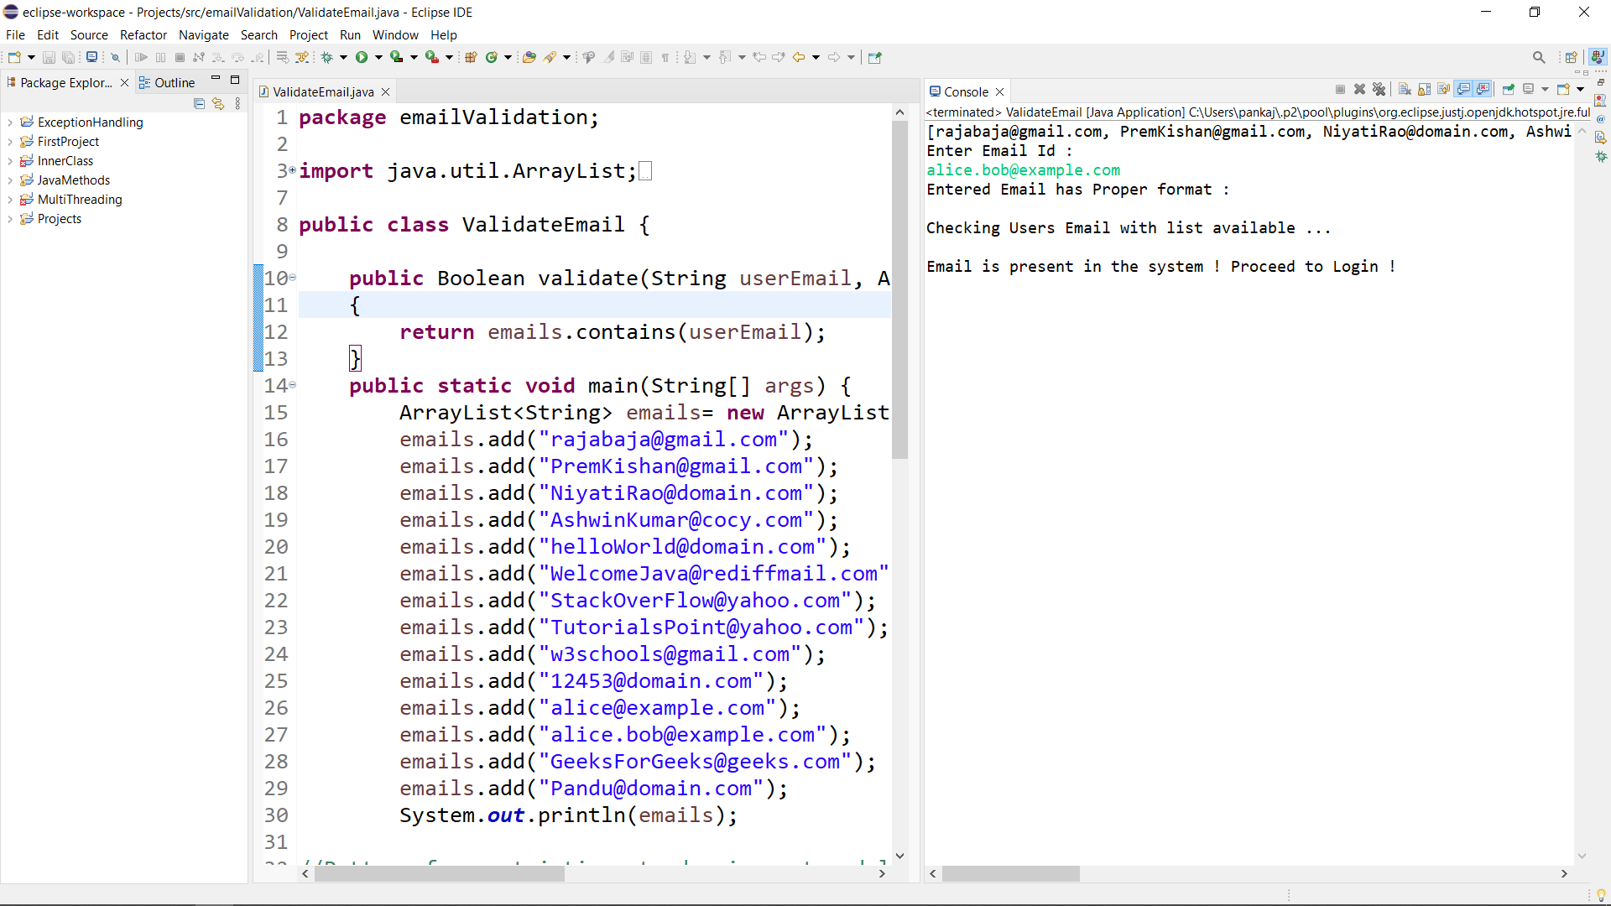

Case 2: Entered Email Id with proper format and not available in the system.

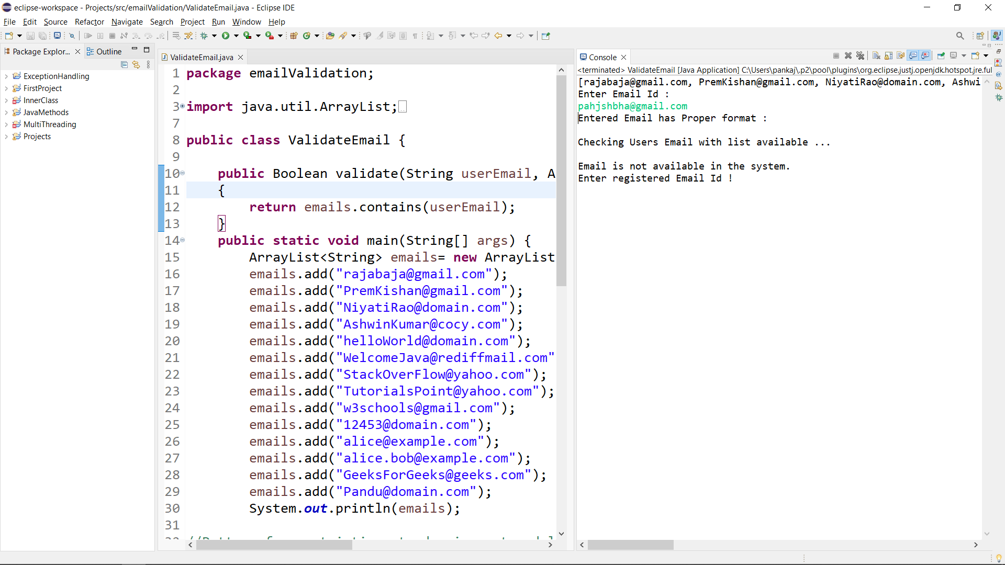

Case 3: Wrong format.

